James Cox

Programing project

Contents

Who it is for: 2

Analysis: 2

How it works: 2

Success criteria: 2

Scope: 2

How well the project went: 2

Possible future extensions: 2

Requirements from client: 3

Writing: 3

Diagrams: 3

How I would: 3

End of client review: 4

Uml class diagram: 4

Maths relating to motion of elements on screen: 4

Design drawings: 5

Table of what happened: 5

Client review: 7

Idea: 7

Why do you want it? 7

What do you want? 7

Question and Answer 8

What do you think of the programme? 8

Does the programme work? 8

Is the programme clear to use? 8

Is the programme fun? 8

Does the physics work? 8

Are the colours ok 8

Rate out of ten 8

How can it be improved? 8

Additional notes: 9

Opinion: 9

Even better if? 9

Program code: 9

Program.cs 9

Ball.cs 26

Question.cs 27

Awncer.cs 30

Awncers.cs 32

Who it is for: Joe Noyes

Analysis: The program is a game that helps people who are struggling with basic math skills (adding, subtraction, multiplying and dividing) and keeping them from seeing it as revision, using a game where you throw the Answer at the Answer box as fast and accurately as possible to score points and beat high scores.

How it works: The user will see a question to answer and choose one of the four options given; they will then click on which one they think is correct and drag backwards until the angle of trajectory they have made will send it into the answer box. If the answer is correct then they will get points and if not a new question will appear.

Success criteria:

S: A game that helps people with the skills add, subtract, times and divide more easily

M: higher score to show that math skills are improving while playing.

A: A game that helps people with the skills add, subtract, times and divide more easily

R: the game will improve maths skills but may not find it as fun as a non-educational game.

T: Completed in under a month

Scope: a game that uses maths and physics to help people struggling with basic math skills to be more confident and help their mental calculations.

# How well the project went:

I believe the project went well because I completed the program and the client was pleased with it. I believe with a bit more time and no write up to do I could extend the project more.

During the programming of the program, I came across a few bugs but I managed to solve them relatively fast so I could continue with the programing and complete the project.

In the success criteria, I believe I completed points; S, M, A and R but not T because I have probably spent over a month, which is why I believe the project went well overall.

# Possible future extensions:

in the future, I would like to add different levels of difficulty, a system to save and compare scores with different players, a Day le challenge mode, rewards / medals for completing goals and possibly more game modes to play.

# Requirements from client:

## Writing:

On paper

## Diagrams:

On paper

## How I would:

Variable difficulties: I think this is a good idea because it would add more to do in the game, I could do this by adding some sort of multiplier to increase the numbers used in the equations and a number that is used as a difficulty multiplier.

Variable timers: I would change the timer based on the difficulty so you have longer or easier questions and shorter on harder difficulties witch may make the game more fun.

Themes: I would have special sprite packs that replace the default sprites to make the game look like the selected theme without effecting the gameplay.

# End of client review:

# Uml class diagram:

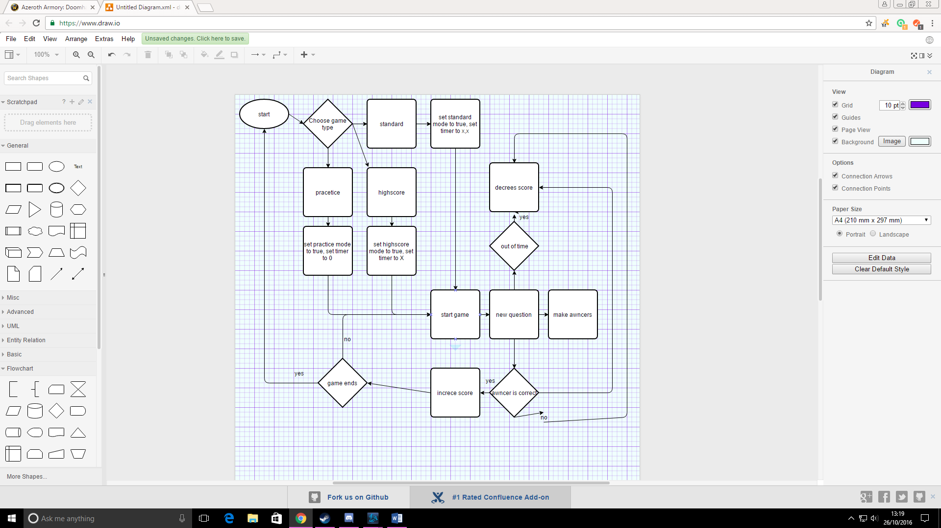

# Maths relating to motion of elements on screen:

If the ball touches the edge, then it reverses the relative velocity.

Depending on how far the player drags their mouse after clicking an answer then set x/y velocity to that.

If x velocity is more than 0 than -1, if x velocity is less than 0 +1. Velocity equation: v = u + at

If the ball is close to the answer box and set as the correct answer, then do the code for the correct answer.

If certain balls y is more than “x” set active to false / destroy it.

If the line that shows the “angle of trajectory” changes re draw/throw arrow.

Arrow = fake ball throwing but drawing a line between each point

The ball

If the screen changes then it spawns balls that are drawn as characters at the top of the screen in a random area, set gravity to true and set x velocity to a random number.

The balls trajectory is based on gravity and the x velocity. Gravity makes the ball go down and the x velocity is increased or decreased until is 0 so the ball is not moving left or right

Design drawings:

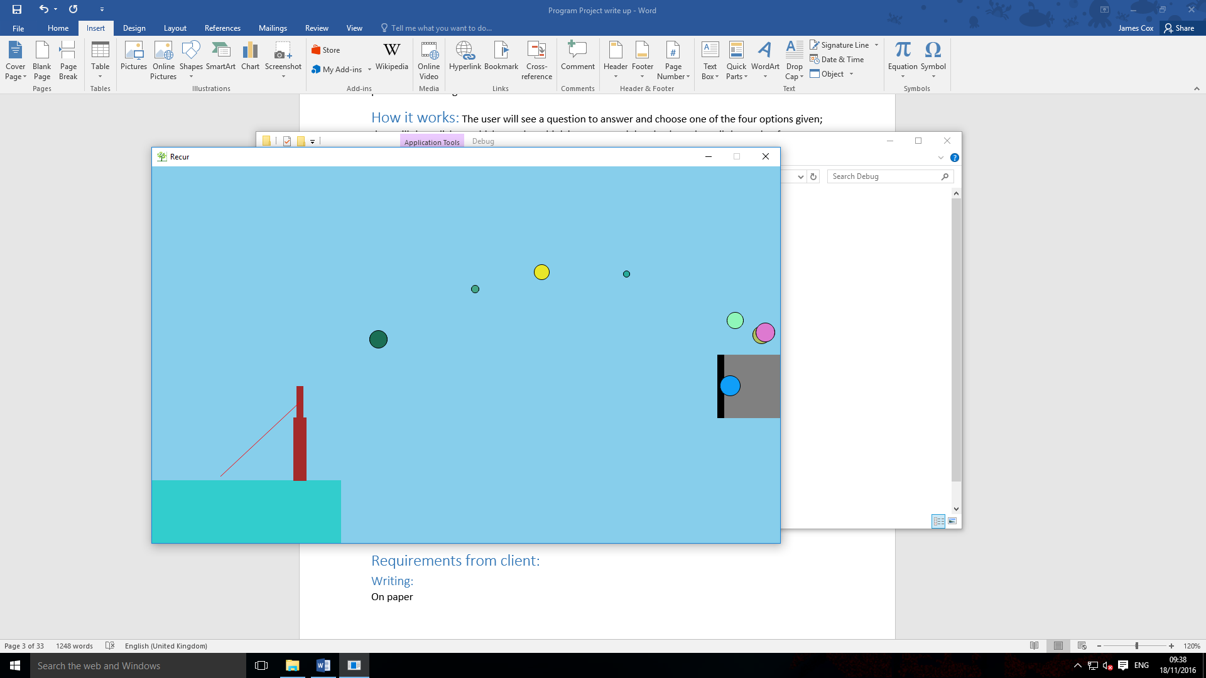

This photo is of the design game and only uses basic shapes using in program features and the base code for the ball moving and the pinging feature to send the ball in a direction to control the ball.

Question

1 + 0 =???

Awncers

1

2

3

4

Awncer box

Check the spelling

# Table of what happened:

|  |  |  |
| --- | --- | --- |
| week | What happened in the week | Screenshot of program |
| 1 | Added sprites / string to sprites  (sprites being drawn to test what it would look like) |  |
| 2 | Added physics |  |
| 3 | Made objects throw able |  |
| 4 | Added questions and changed colours |  |
| 5 | Added answer |  |
| 6 | Added answer goal |  |
| 7 | Added score |  |
| 8 | Added menu and game modes |  |
| 9 | Added how to play |  |

Use merge sort to create a scoring folder and sort score for the highest score table. Show your evidence for this.

# Client review:

Idea: A method to be used to help pupils practise their math skills. This would be based around multiple choices questions and have some interactive and fun method for selecting the answers.

## Why do you want it?

I want it so that pupils being taught maths will essentially be tricked into learning their math skills. Maths lessons are difficult for a large number of pupils, so they tend to avoid doing anything related to them. Hiding maths skills behind a fun game will help them learn the basic skills while bypassing their reluctance to engage with mathematics.

## What do you want?

A nice fun game that has randomly generated multiple choice maths questions based on multiplication, addition, subtraction and division.

## Question and Answer

### What do you think of the programme?

Pretty. I really like it. I think it is quite impressive. It’s a nice way of letting students to practise their abilities. I like the style and think it is very nice the controls are nice and simple. I really like the practise mode it very easily shows what they should be doing. I really like this. I think there are people that can already benefit from it as it currently stands. I don’t know how portable it is to different levels, but if it portable it could be easily sold.

### Does the programme work?

Yes, it does. I didn’t notice any bugs, but the only qwerk was after you got something wrong, it wasn’t as quick to allow you to take the next one.

### Is the programme clear to use?

The practise mode is fantastic.

### Is the programme fun?

Yes. I think if it could be shared with friends and had a scoring system then people could quite easily get involved in it quickly. I think it is something they can enjoy a lot and

### Does the physics work?

Yes, it does

### Are the colours ok

I like the red and yellow. It’s quite a nice contrast for what it is. I thought it wasn’t going to be as good as it is because of the colours, but now I think they work really well.

### Rate out of ten

If it is on a scale of this type of game, I would give it an 8 or 9 out of ten. As it is well put together, looks good and is a nice development. Some others have more images though. Very nearly an outstanding game

### How can it be improved?

You could do a theme and resale it with different themes e.g. my little pony, baseball version, football version. And then you and have global leader boards to give players something to aim for.

## Additional notes:

## Opinion:

This is one of the best examples of a learning game I have seen. I recently worked with a University student on their project producing educational games and theirs were not as advanced as this.

## Even better if?

Having variable difficulties or timers will be useful to have. This would allow pupils to start at a simple level and then increase the difficulty for bigger rewards.

Having themes would be great as it could be sold to a wider audience based on their interest in the Simpsons, my little pony or Pokémon

# Program code: Annotate the key aspects in your coding to explain what it does on the game and the design. (use text boxes)

## Program.cs

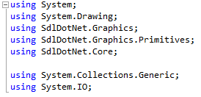

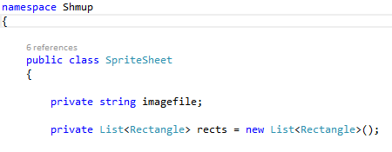

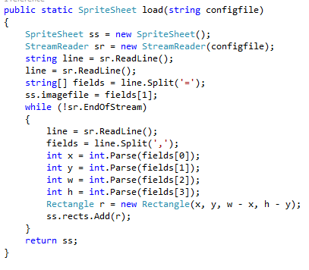

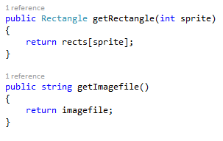

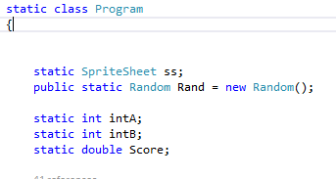

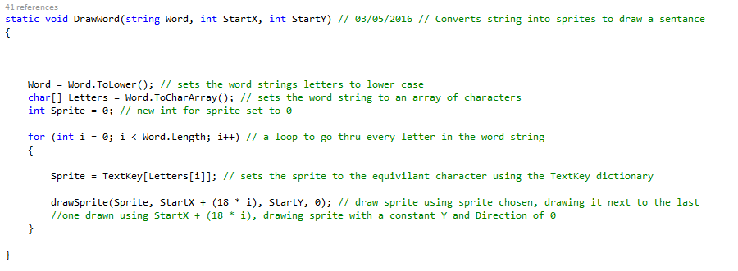

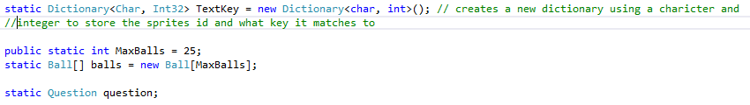

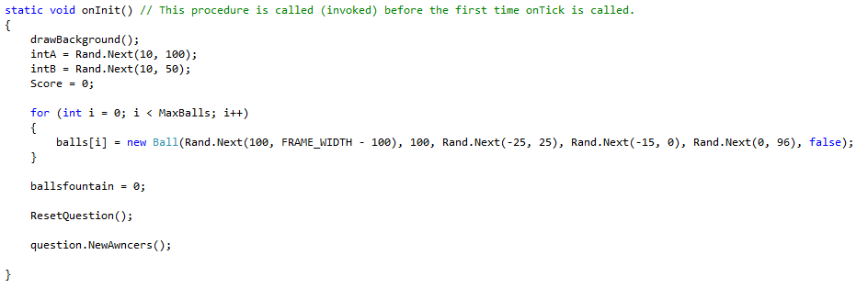

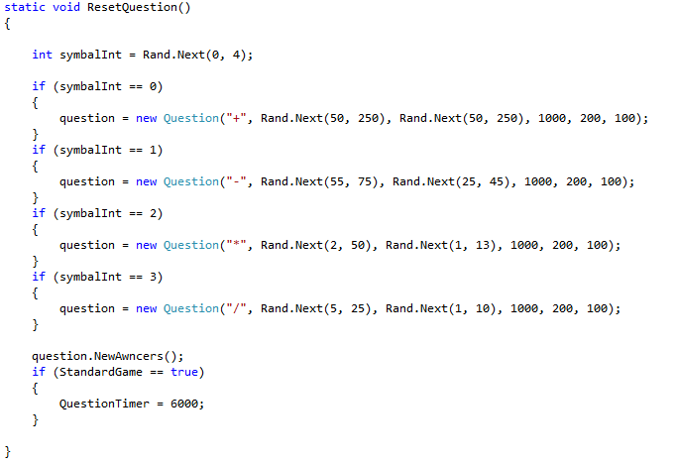

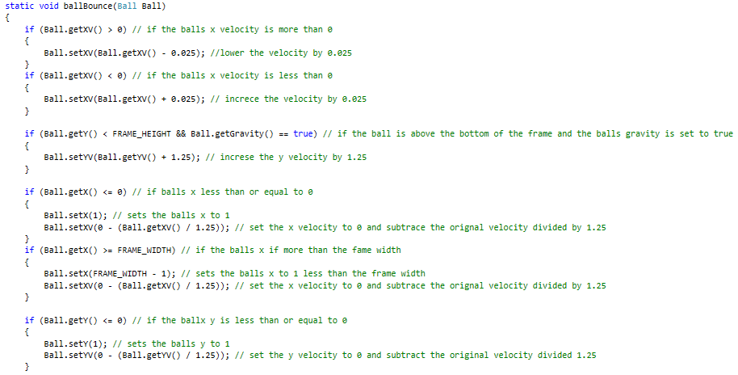

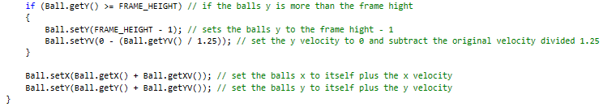

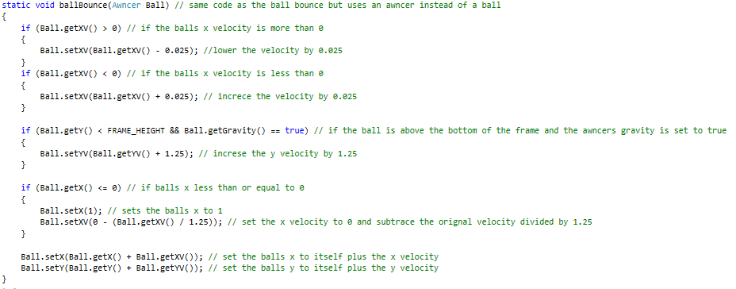

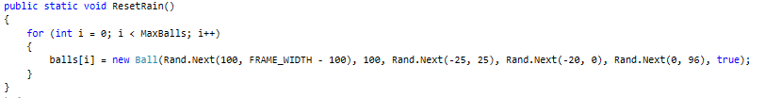

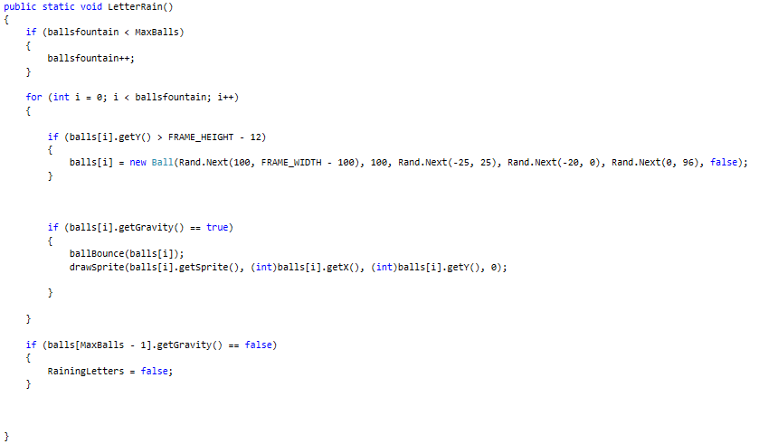

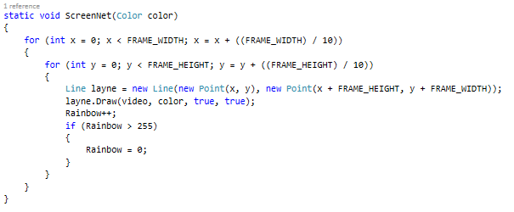

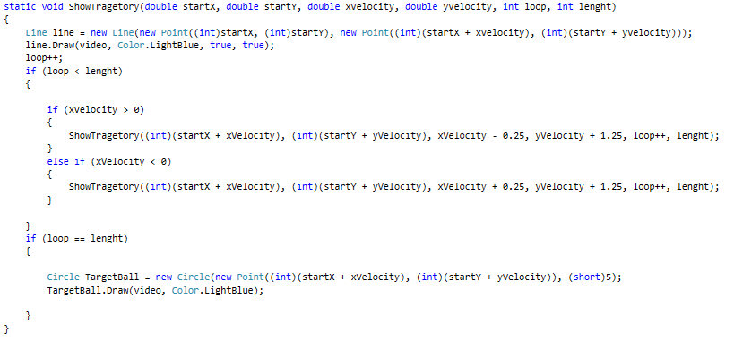

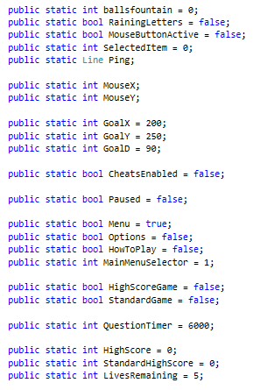



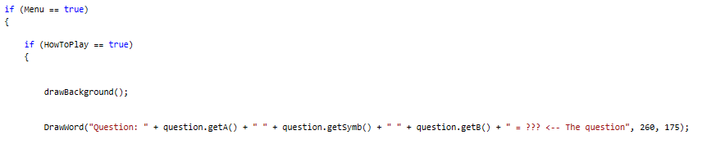

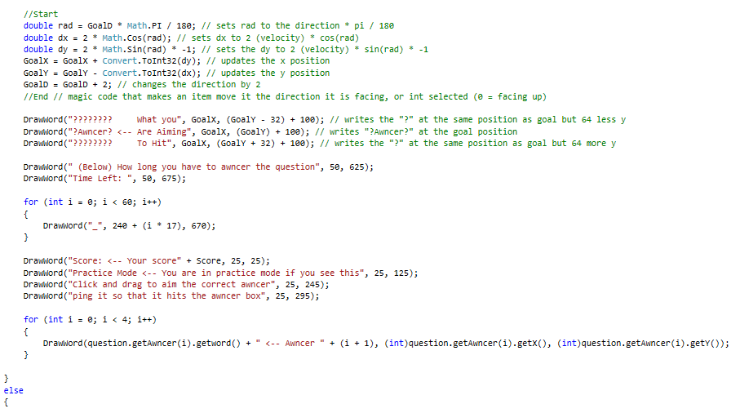

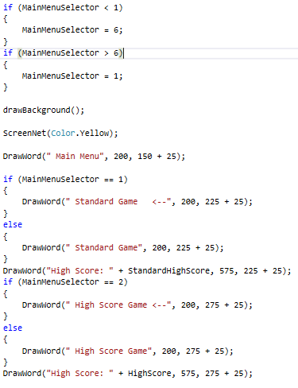

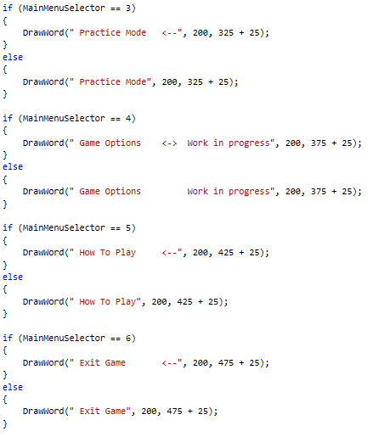

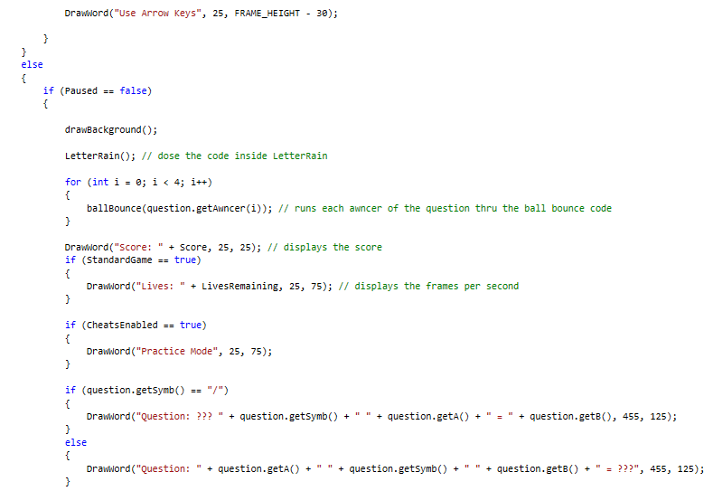

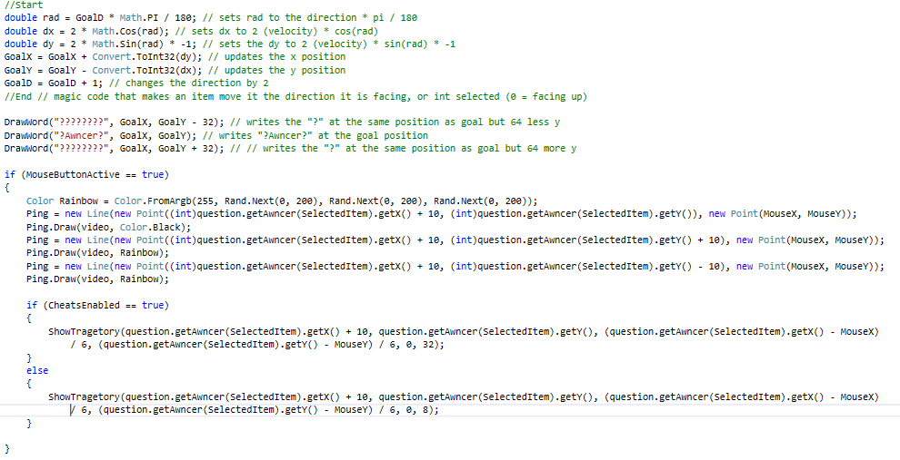

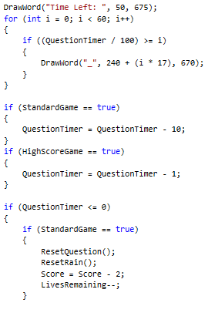

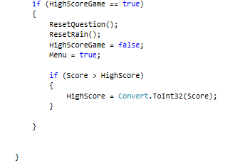

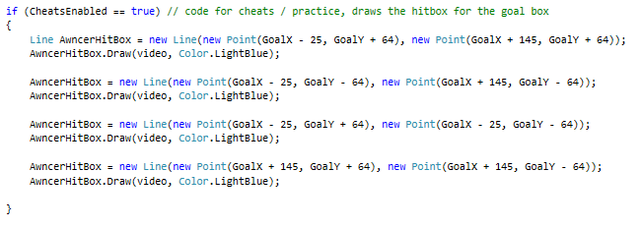

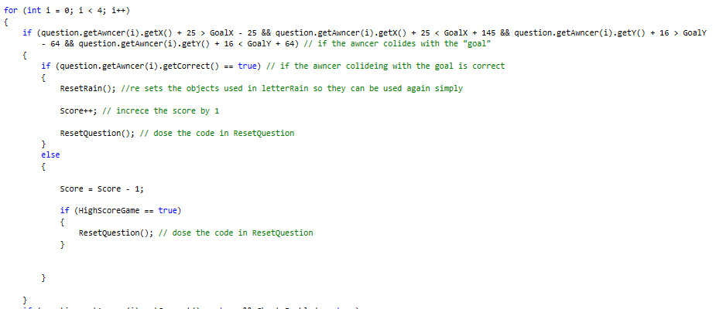

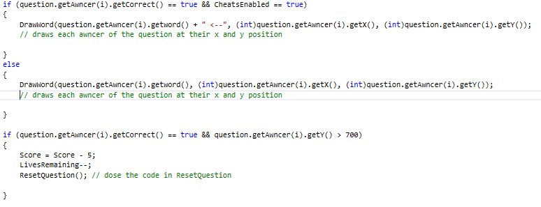

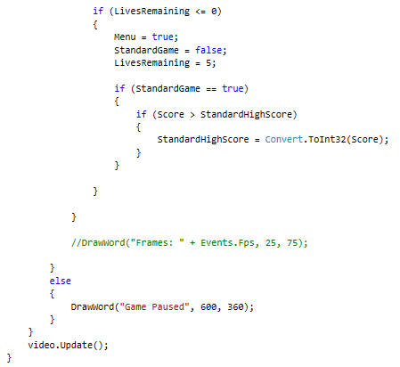

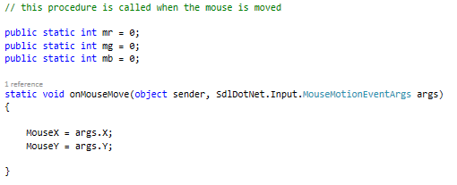

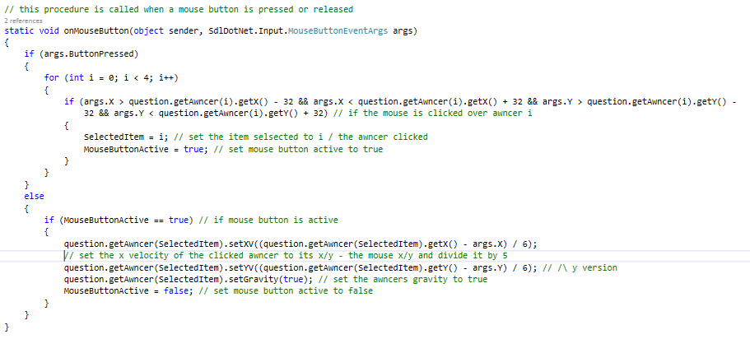

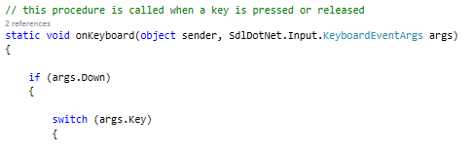

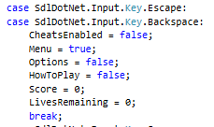

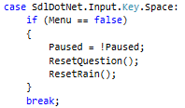

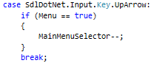

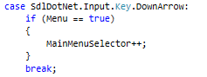

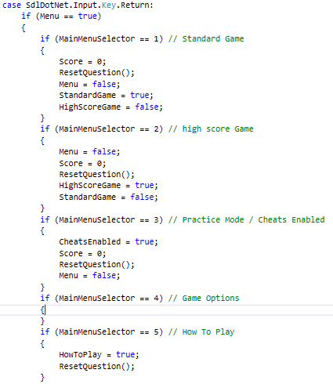

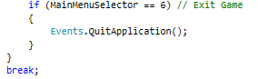

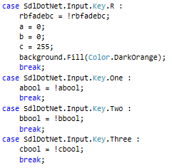

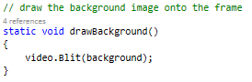

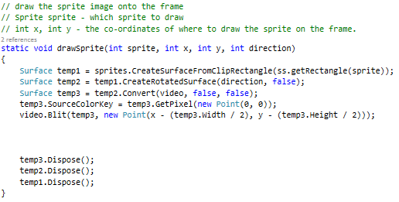

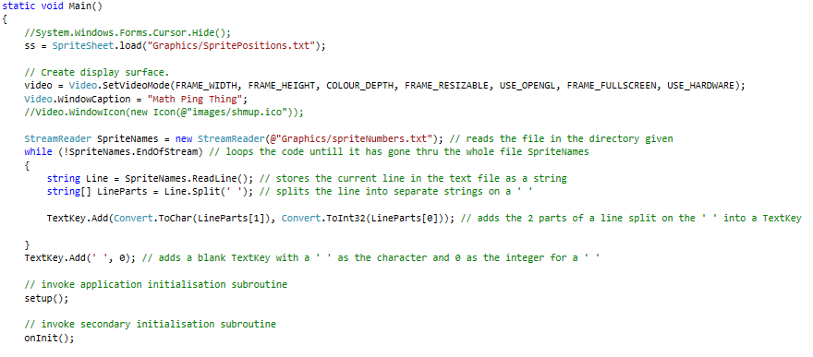

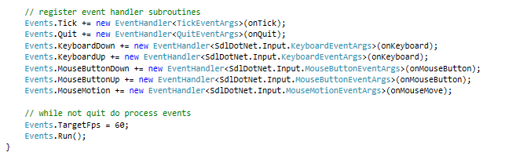

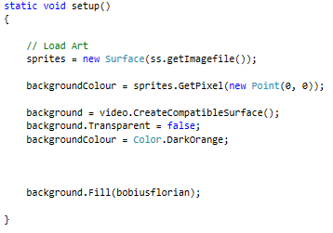

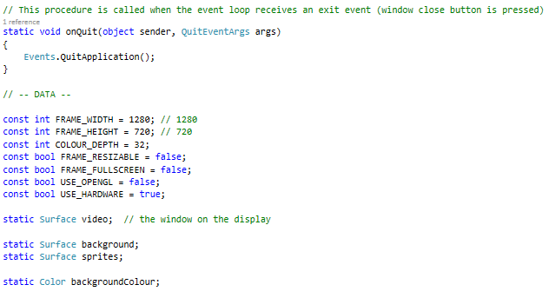

## Ball.cs

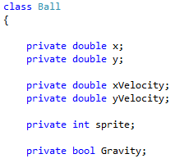

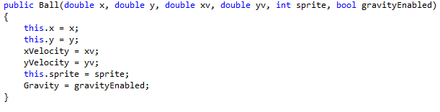

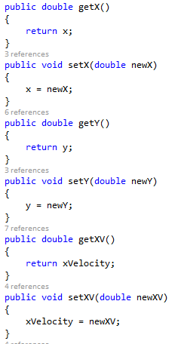

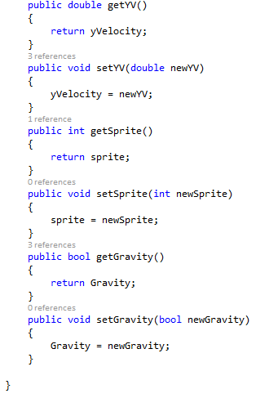

## Question.cs

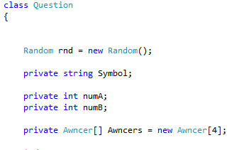

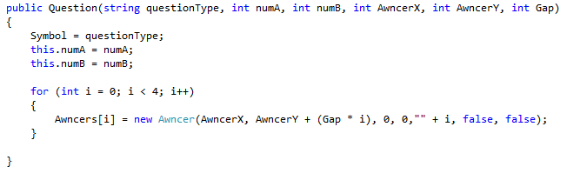

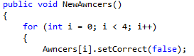

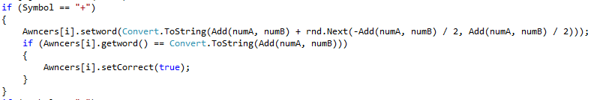

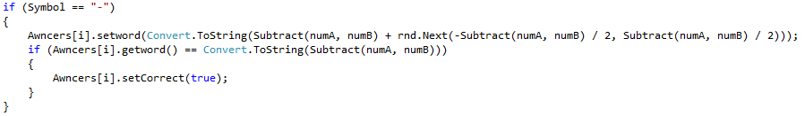

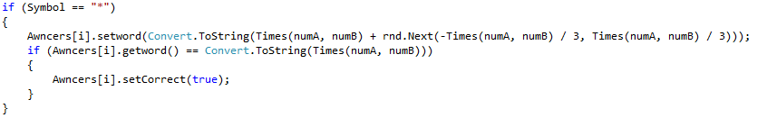

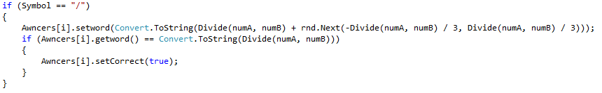

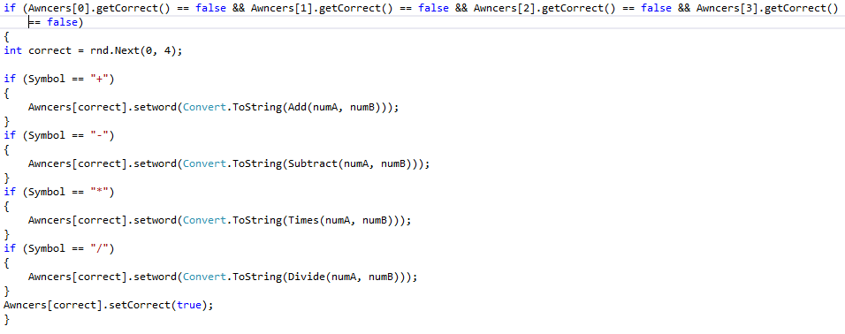

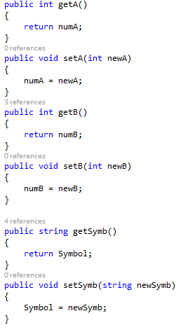

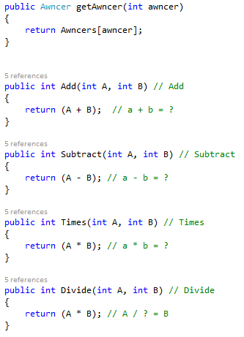

## Awncer.cs

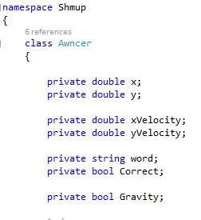

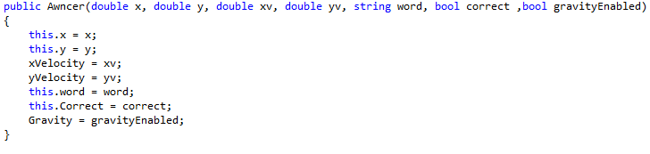

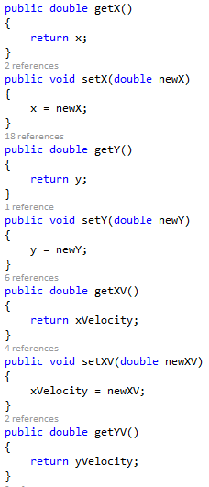

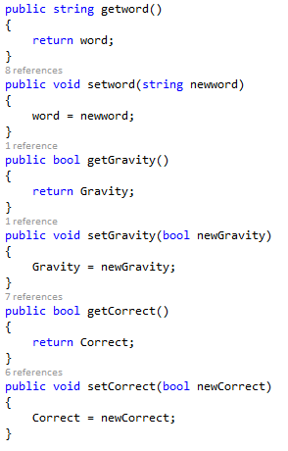

## Awncers.cs

